SoC8767 Gas Sensor SoC: Packaging and Bonding Documentation
Prepared by Farah Ridha for IHP (assembly / packaging request). Design: SoC8767, release v.1.0.0. Repository: https://github.com/CDTA-DMN/IHP__SoC8767

1. Request summary
We request assembly of the SoC8767 die into a QFN-24 package (4 mm x 4 mm, 0.5 mm pitch, 6 leads per side, exposed die paddle). The die has 16 peripheral bond pads (4 per side). On each side the 4 pads connect to the 4 central leads; the 2 corner leads of each side are left unconnected (NC). The substrate (VSS) is also down-bonded to the exposed paddle.

2. Die pad list
Pad numbering runs counter-clockwise starting at the top of the left side: P1 to P4 left (top to bottom), P5 to P8 bottom (left to right), P9 to P12 right (bottom to top), P13 to P16 top (right to left). Coordinates were extracted from the GDS. Origin (0,0) is the centre of the die, Y up, in um; the second pair is relative to the die center.
Pad | Signal | Side | X, Y (um, die centre origine) | X, Y (um, lower-left of the die) | Direction of Pad | Function (from design labels)
P1 | BGR_1V0 | Left | -407.5, 142.9 | 92.5, 642.9 | Analog In/Output | 1.0 V bandgap reference output
P2 | VSS | Left | -407.5, 47.9 | 92.5, 547.9 | Supply / Ground | Ground / substrate
P3 | IN_SENS | Left | -407.5, -47.6 | 92.5, 452.4 | Analog Input | Sensor analog input to ADC
P4 | ALARM | Left | -407.5, -142.5 | 92.5, 357.5 | Output | Alarm output
P5 | RESET | Bottom | -142.5, -407.5 | 357.5, 92.5 | Input | Reset input
P6 | VDD_1V2 | Bottom | -47.6, -407.5 | 452.4, 92.5 | Power / Output | 1.2 V LDO node
P7 | AD0 | Bottom | 47.9, -407.5 | 547.9, 92.5 | Input | I2C device address bit 0 (Input, active high/low) with internal pull-down/pull-up.
P8 | ENABLE | Bottom | 142.9, -407.5 | 642.9, 92.5 | Input | Enable input
P9 | I_SDA | Right | 407.5, -142.5 | 907.5, 357.5 | Input | I2C SDA (input side)
P10 | I_SCL | Right | 407.5, -47.6 | 907.5, 452.4 | Input | I2C SCL (input side)
P11 | O_SDA | Right | 407.5, 47.9 | 907.5, 547.9 | Output | I2C SDA (output side)
P12 | O_SCL | Right | 407.5, 142.9 | 907.5, 642.9 | Output | I2C SCL (output side)
P13 | CLK_D | Top | 142.9, 407.5 | 642.9, 907.5 | Input | Digital clock pad
P14 | CLK_A | Top | 47.9, 407.5 | 547.9, 907.5 | Output | Analog clock pad
P15 | VDD_1V2 | Top | -47.6, 407.5 | 452.4, 907.5 | Power / Output | 1.2 V LDO node
P16 | VDD_3V3 | Top | -142.5, 407.5 | 357.5, 907.5 | Supply / Power | 3.3 V external supply

3. QFN-24 package and pin mapping
Pin 1 is the first lead on the left side nearest the top-left corner dot. Pins run counter-clockwise: 1 to 6 left (top to bottom), 7 to 12 bottom (left to right), 13 to 18 right (bottom to top), 19 to 24 top (right to left).
Pkg pin | Pad | Signal | Notes
1 | - | NC | Corner lead, no bond
2 | P1 | BGR_1V0
3 | P2 | VSS | Also down-bonded to DAP
4 | P3 | IN_SENS
5 | P4 | ALARM
6 | - | NC | Corner lead
7 | - | NC | Corner lead
8 | P5 | RESET
9 | P6 | VDD_1V2
10 | P7 | AD0
11 | P8 | ENABLE
12 | - | NC | Corner lead
13 | - | NC | Corner lead
14 | P9 | I_SDA
15 | P10 | I_SCL
16 | P11 | O_SDA
17 | P12 | O_SCL
18 | - | NC | Corner lead
19 | - | NC | Corner lead
20 | P13 | CLK_D
21 | P14 | CLK_A
22 | P15 | VDD_1V2
23 | P16 | VDD_3V3
24 | - | NC | Corner lead
DAP | P2 (VSS) | VSS

5. Bonding diagram
The to-scale top view (lead frame, die, 16 pads, wires and DAP down-bond) is provided as the following pictures
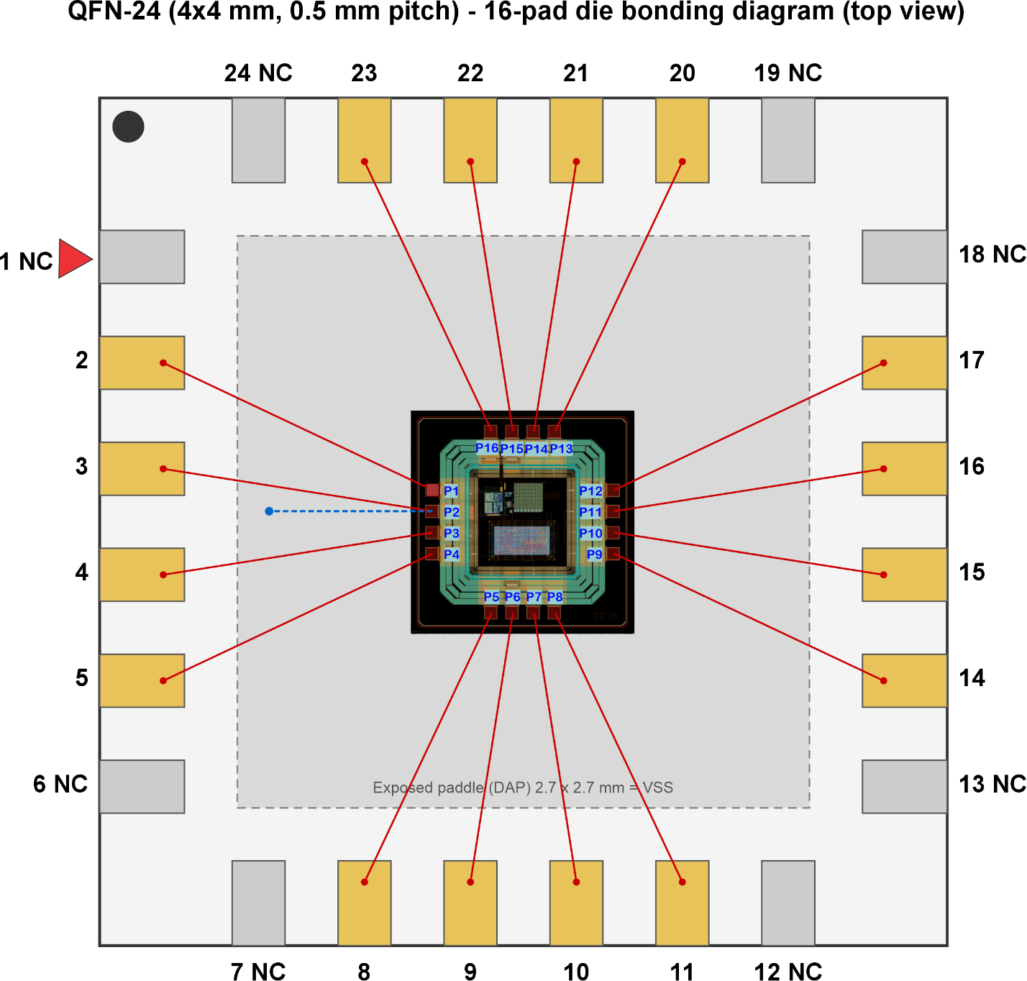

6. Assembly requirements and requests
- Wire bonding: gold wire, ball-wedge, diameter to be proposed by IHP assembly for a 55.8 um pad opening.
- Die attach: conductive adhesive onto the exposed paddle, so the die substrate is grounded through the backside as well as through the VSS down-bond.
- Exposed paddle: connected to VSS (printed circuit board ground).
- VSS pad (P2): one wire to lead 3 and one wire to the paddle. We ask IHP to advise whether this is done as two wires on the pad or as a stitch bond on the first ball.
- NC leads (1, 6, 7, 12, 13, 18, 19, 24): left unbonded and electrically floating.

